**1. Parameter estimation for ARMA model**

The idea is to measure the signal based on it, and do the calculations within a sampling interval. This approach is important when a fast result is required and can be improved later, or when there is a time-varying system whose parameters change over time. The main recursive least-squares(RLS) method is given by the following equations:

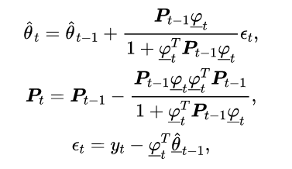

Where θt is a vector of the estimated parameters at time step t. The initial vector with 6 zeros in the files is Th = zeros(6,1). Matrix Pt is the covariance matrix calculated at t, the initial matrix is usually assumed to be P0 = pI for p >0. In order to accelerate estimation in the first steps of the algorithm, one can use formulae including a forgetting factor, λt change our formulas of the recursive least-squares(RLS) method is :

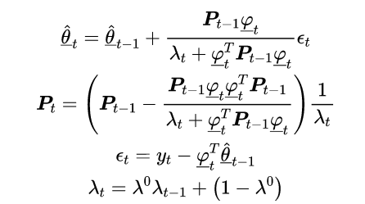

The following image is a modified simulink diagram that also introduces the calculation formula, and the original data file imported is "*model10.slx*" :

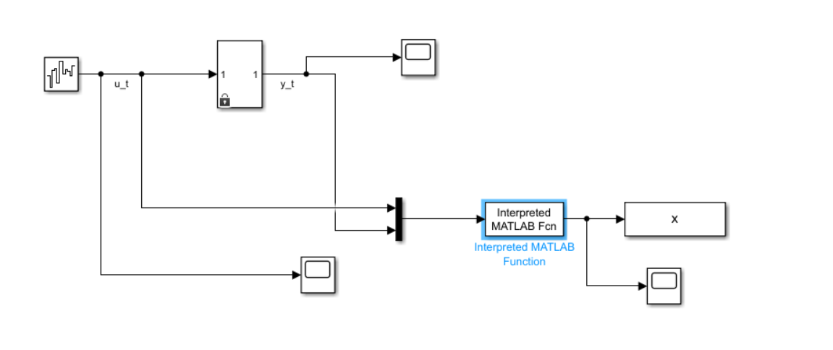

To implement the initial values of Theta and P, the file *initial.m* with the initial values is created, where the initial variables are set to global variables. The input and output vectors are set as global variables, initially empty. Because the input and output vectors are collected, it is necessary to wait for the vector to be filled to facilitate the acquisition of the vector as input and output from the third element. vector t consists of the inputs collected at each time step (-yt) and (ut), and then the elements from that vector are acquired to connect the vector phy. this is implemented in the *myFunction.m* file.

During the simulation, the stop time in Simulink is 10000.0. From the simulation we get the following parameters.

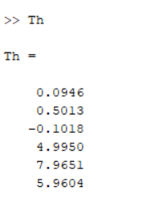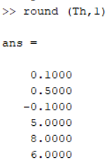

With the Plot command, outputting the final line graph of plot myFunction, we can get the following line graph :

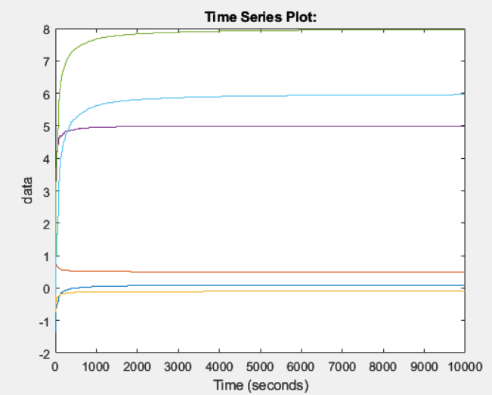

For the parameters, a transfer factor is used to finally obtain a discrete transfer function for a model with a sampling time of 0.01. The model uses theta structure:

model =

Discrete-time ARMAX model: A(z)y(t) = B(z)u(t)

A(z) = 1 + 0.1 z^-1 + 0.5 z^-2 - 0.1 z^-3

B(z) = 5 z^-1 + 8 z^-2 + 6 z^-3

Sample time: 0.01 seconds

**2. Parameter estimation for a stochastic system**

The ARMAX model is a combination of the AR and MA models (moving average applies to the disturbance) with additional, exogenous input (x). The model is therefore given by the equation :



Where is white noise with expected value zero and the polynomials are given as follows:

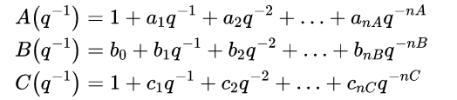

An Output Error (OE) model is a mathematical representation of a dynamic system that can be used to model input-output relationships. It is a combination of an AutoRegressive (AR) model and a Moving Average (MA) model. The general form of an OE model can be represented as:

y(t) = A(q-1) * y(t-1) + B(q-1) * u(t-1) + e(t)

To find the polynomials A(z) and B(z) for the ARMA system, you can express the AR and MA components in terms of polynomials in z:

A(z) = 1 - phi1z^-1 - phi2z^-2 - ... - phipz^-p

B(z) = 1 + theta1z^-1 + theta2z^-2 + ... + thetaqz^-q

The following image is a modified simulink diagram that also introduces the calculation formula, and the original data file imported is "*model10_oe.slx*" :

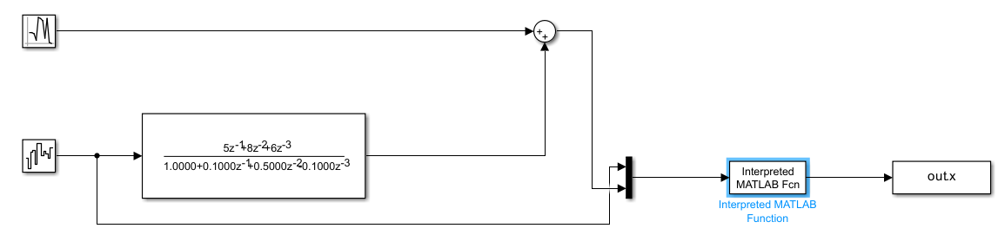

In this example, we use the recursive least squares (RLS) method for system identification. The RLS method was chosen because it is an efficient method that can handle large data sets and is suitable for online identification of systems, which makes it a suitable method for the case where we previously obtained a model but now we try to identify the system parameters.

During the simulation, the stop time in Simulink is 10000.0. From the simulation we get the following parameters.

